Mechanical Design
3.1 3D CAD Model and System Overview
The mechanical design integrates a 6-DOF robotic manipulator onto the mobile chassis using an elevated modular mounting structure. This configuration maximizes the operational workspace while maintaining navigational capabilities. This section presents the 3D CAD model, payload mounting structure, component placement rationale, manufacturability, and structural justification of the mechanical design.
As illustrated in Fig. 2, the system features a myCobot 280 PI manipulator mounted on an elevated deck. The RPLidar A2M12 and RealSense D435i are strategically positioned to ensure unobstructed fields of view for autonomous navigation and obstacle avoidance.
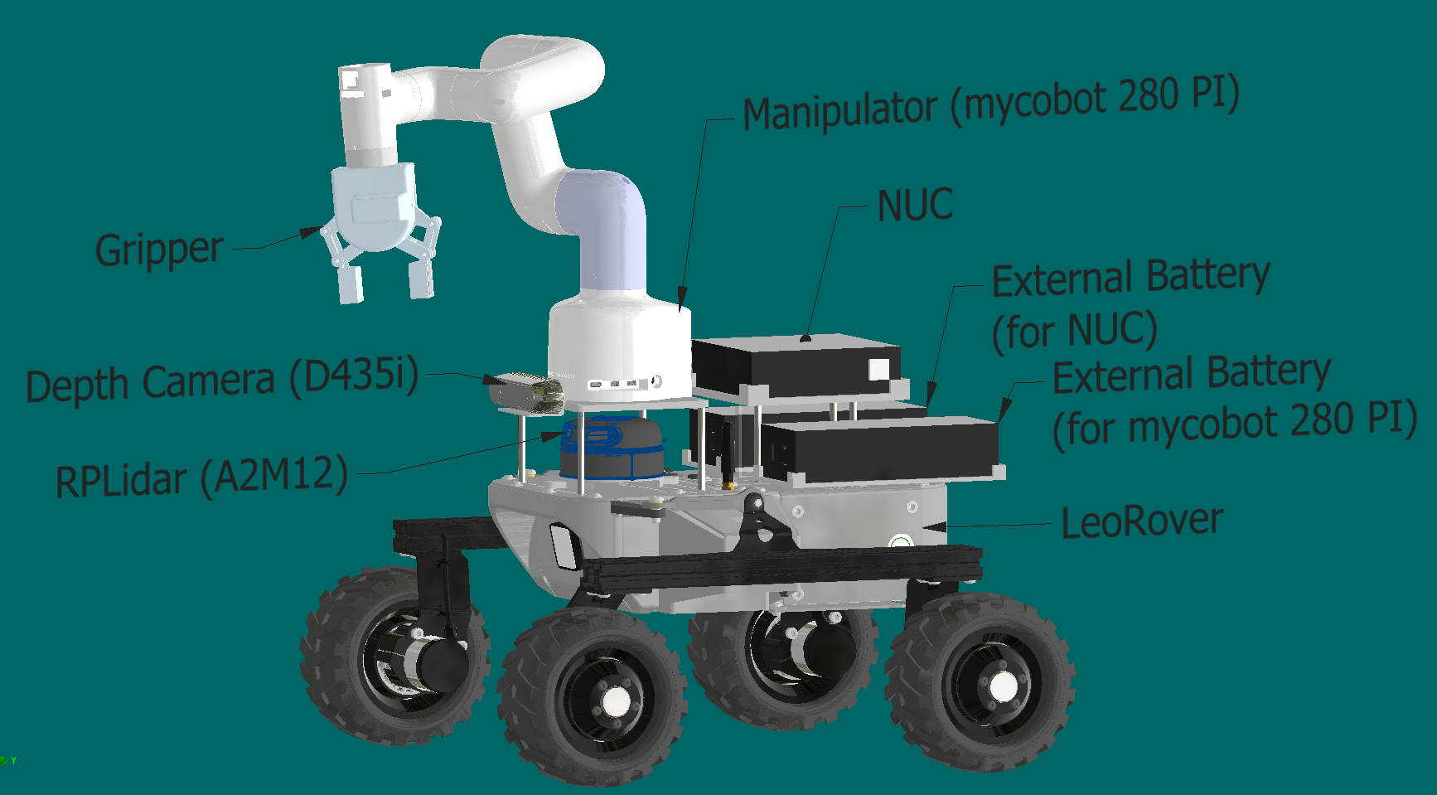 | 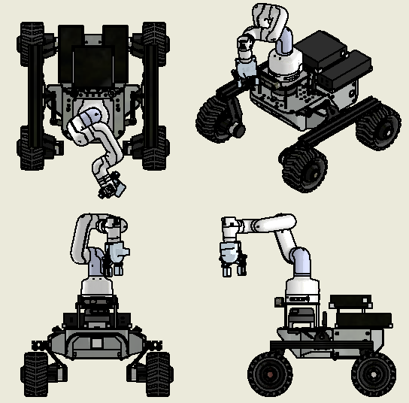
(a) | (b)
Fig. 2. Mobile manipulator platform based on LeoRover. (a) Annotated isometric view identifying key components. (b) Orthographic and isometric views showing the overall geometry.
3.2 Payload Mounting Structure Design
The payload mounting structure provides the main mechanical interface between the manipulator, onboard computing hardware, power modules, and the LeoRover chassis. The manipulator base plate is elevated from the rover deck by four hex standoff spacers, while a separate rear platform supports the NUC using another set of standoff supports. This arrangement defines a clear structural separation between the manipulator platform, computer platform, and the lower chassis-mounted power modules. An interactive version of the CAD model is available via Autodesk Fusion at https://a360.co/4ly5kZV
As shown in Fig. 3, the system is arranged as a vertically stacked modular assembly. The exploded view illustrates the relationship between the manipulator platform, LiDAR region, NUC platform, battery platforms, and rover chassis, together with the main assembly direction indicated by the guide lines. This representation clarifies how the elevated platforms are supported by discrete hex standoff spacers and how the major subsystems are distributed across the chassis in a compact and modular configuration.
Key geometric dimensions of the mounting structure are provided in Fig. 4. The top view shows the principal platform footprint and support spacing, while the side view shows the elevation of the upper platforms relative to the rover body. These dimensioned CAD views clarify the geometric basis of the mounting arrangement and provide the main dimensions used in the packaging and structural discussion.
The spacer-supported arrangement reduces material around the LiDAR, creating more open space on the rover deck and minimising obstruction. At the same time, four-point support on each platform maintains a stable load path into the chassis. Platform height can also be adjusted by selecting different spacer lengths when required by clearance or routing constraints.
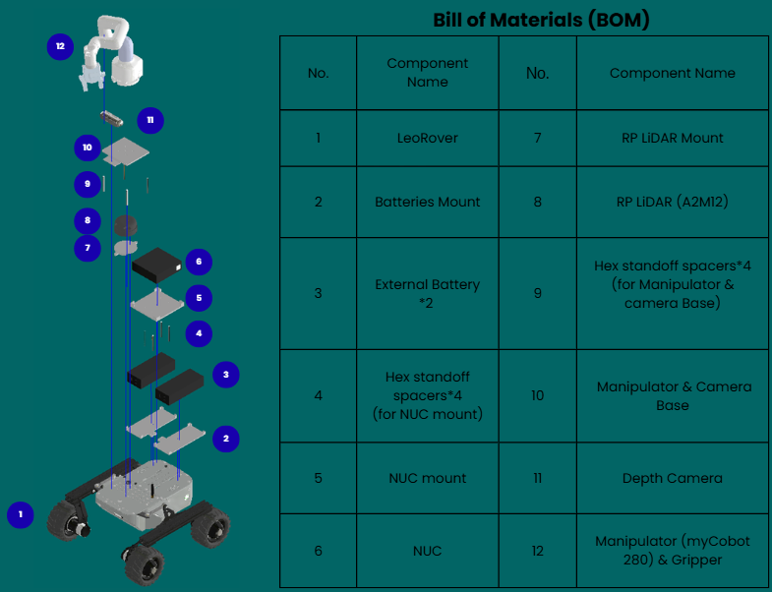
Fig. 3. Exploded view of the mounting structure assembly with Bill of Materials (BOM)
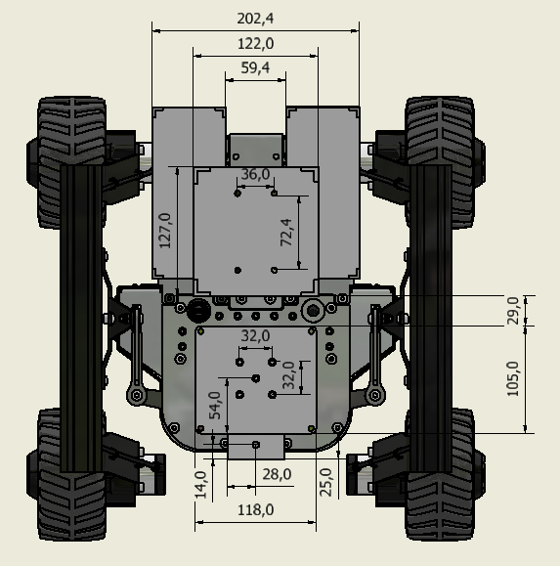 | 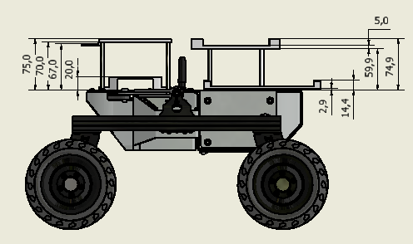
(a) | (b)
Fig. 4. Dimensioned CAD views of the payload mounting structure. (a) top view showing principal platform footprint and support spacing; (b) side view showing platform elevations and vertical packaging arrangement.
3.3 Component Placement Trade-offs
The arrangement of hardware components involves a critical balance between sensor visibility, mechanical interference, and system stability. The manipulator, LiDAR, depth camera, onboard computer, and batteries must be packaged within the physical constraints of the LeoRover chassis without compromising core functionality. As shown in Fig. 5, the final layout distributes these subsystems in a compact manner while preserving access to the manipulator workspace and the main sensing region.
- Sensor Visibility vs. Structural Support
Reducing LiDAR obstruction is a central objective of the layout. As illustrated in Fig. 4(a), the use of four discrete hex standoff spacers for each upper platform reduces the effective structural cross-section within the sensing region. This creates a more open environment around the LiDAR and supports cleaner 360-degree scanning with fewer blind regions introduced by the supporting hardware.
- Manipulator Elevation and Clearance
The manipulator is elevated above the main rover body because practical arm motion and deck clearance require the base to sit above the surrounding components. As shown in Fig. 5(b), the standoff-supported platform provides this elevation with a lighter and more open structure, offering a balanced compromise between maintaining reach for pick-and-place tasks and avoiding unnecessary interference with nearby sensors and platform components.
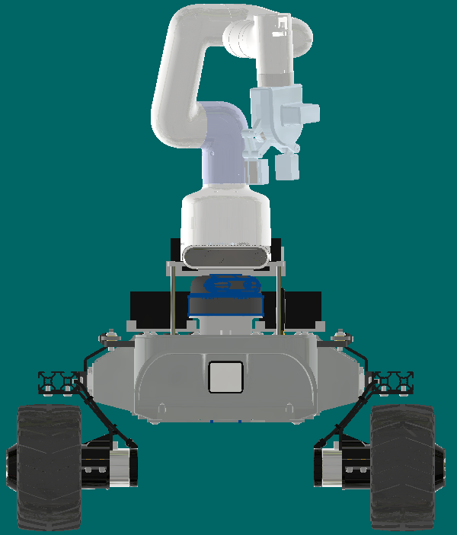 | 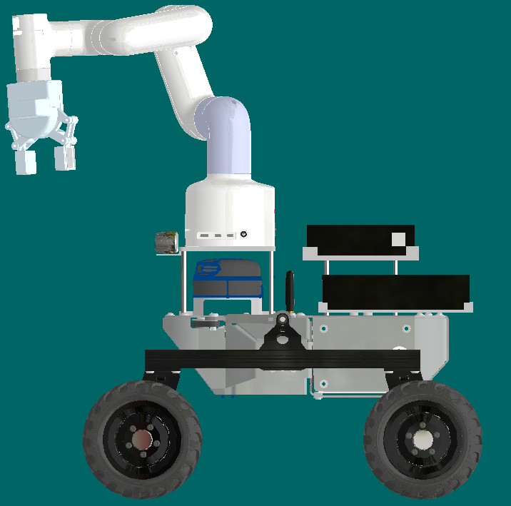
(a) | (b)
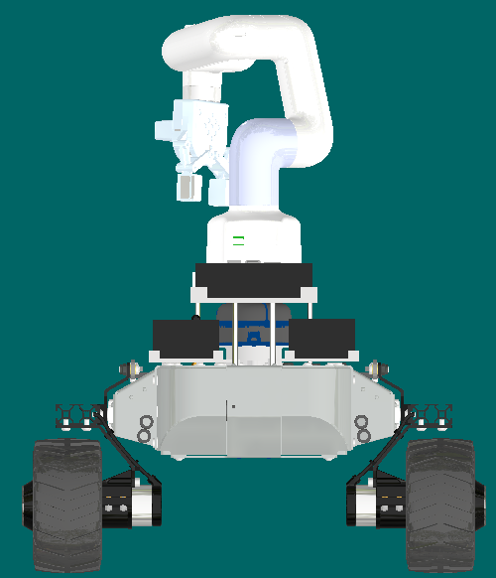 | 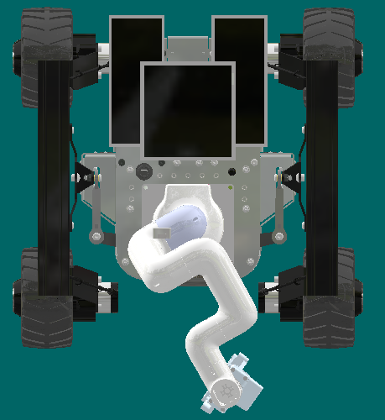
(c) | (d)
Fig. 5. Component placement views of the final system layout: (a) front view; (b) side view; (c) rear view; and (d) top view, illustrating sensor clearance, platform stacking, subsystem arrangement, and support footprint.
- Computer and Battery Packaging Strategy
As shown in Fig. 6, the rear packaging arrangement places the NUC on its own elevated platform, while two batteries of identical size are mounted on the LeoRover body below the NUC region. This layout improves packaging consistency, keeps the upper structure organized, and reduces clutter around the manipulator working area. It also supports cleaner cable routing by separating the computing platform from the lower-mounted power modules.
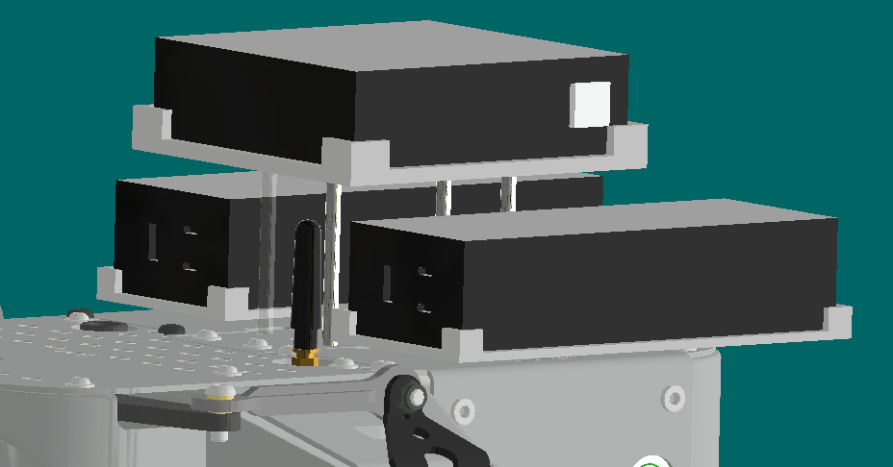
Fig. 6. Rear packaging arrangement showing the elevated NUC platform and the two identical batteries mounted below on the LeoRover body.
- Overall Trade-off Outcome
Overall, the layout resolves the core conflicts between sensor visibility, manipulator clearance, and mass distribution while remaining compatible with the physical constraints of the LeoRover platform.
3.4 Manufacturability and Suitability Analysis
The structure was designed to minimize fabrication complexity by combining simple flat plates with standard hex standoff spacers. As shown in Fig. 7, this approach limits bespoke geometry and produces a clear, repeatable construction based on a small number of straightforward parts.
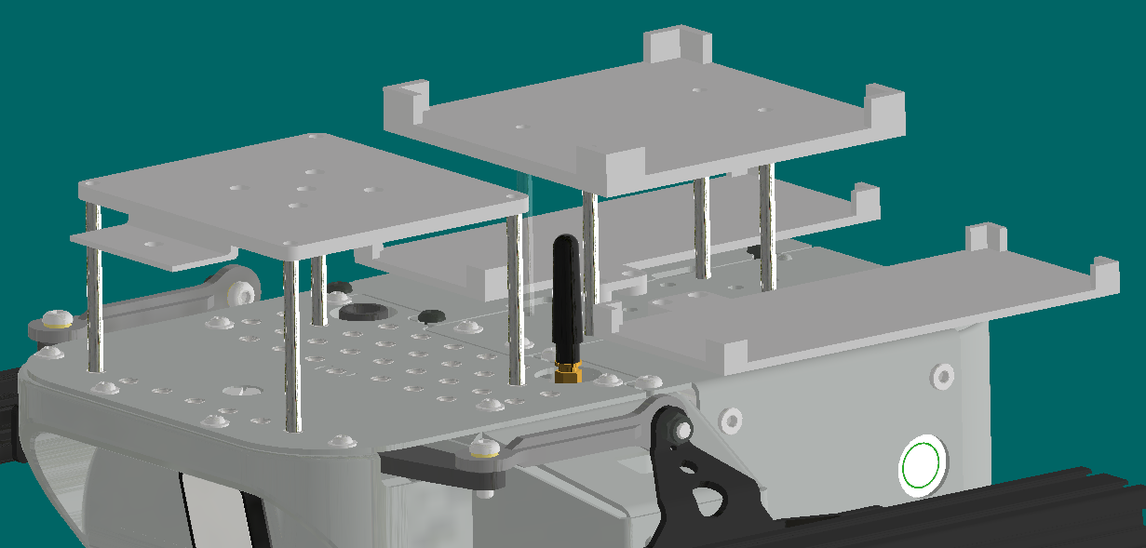
Fig. 7. Mounting structure detail showing the flat plates and hex standoff spacer arrangement.
- Manufacturability
From a manufacturing perspective, the arrangement requires fewer custom structural parts and simplifies fabrication. The mounting plates remain relatively easy to produce, while platform elevation is achieved using standard spacers rather than a complex integrated frame. This reduces fabrication effort, shortens iteration time, and makes dimensional adjustment more practical if platform heights need to change later.
The architecture also improves serviceability during prototyping and integration. Individual plates, spacers, or local fasteners can be removed and replaced without reworking the entire structure, which is beneficial when hardware packaging or sensor interfaces require minor refinement.
- Suitability and Structural Integrity
Structurally, the standoff-based architecture provides a direct load path from the manipulator and NUC platforms into the rover deck. Each elevated platform is supported at four points, giving stable and symmetric load transfer while avoiding unnecessary supporting material. This makes the arrangement suitable for the intended operational loads at the PDR stage.
3.5 Structural Assessment and Design Justification
Engineering judgement and first-order loading estimates indicate that the structure is fit for purpose for the intended mobile manipulation tasks. The manipulator load is modest in absolute terms, and the mounting structure transfers this load through compact and direct structural paths into the rover body. Within the scope of this Final Design Review submission, a detailed finite element analysis has not been included; however, the simplified calculations and structural layout provide sufficient justification for the current design choices.
- Load Analysis
The manipulator load can be estimated from the myCobot 280 PI self weight and intended payload. Using approximately 850 g for the manipulator mass and 250 g for the payload, the total supported mass is about 1.1 kg, corresponding to a static vertical load of approximately 11 N. Under ideal symmetric loading, this gives an average static load of about 2.75 N per support.
To account conservatively for manipulator motion, rover acceleration, and minor dynamic disturbances, a dynamic amplification factor of 2–3 was applied. This gives an equivalent total load of approximately 22–33 N, or about 5.5–8.25 N per support. These values remain low in absolute terms and indicate that the mounting structure is not highly stressed under the intended operating conditions.
- Mounting Interface Assessment
Both the manipulator platform and the NUC platform are supported through discrete standoff connections fixed into the rover deck interfaces. This creates a direct and inspectable load path, avoids long unsupported spans, and keeps the structure compact. Because each platform is supported at four corners, the arrangement provides stable load transfer. Crucially, this wide four-point stance effectively resists the overturning moments generated when the manipulator is fully extended, reducing the likelihood of local rocking compared to a cantilevered support concept.
- System Stability and Mass Distribution Strategy
The low mounted battery layout contributes positively to overall stability by keeping a significant portion of the system's mass close to the chassis. This helps maintain a lower center of gravity than an elevated power module arrangement and reduces the pitching tendency that can occur when the manipulator is extended. From a mechanical perspective, this mass distribution is consistent with stable mobile manipulation and complements the direct four-point support arrangement used for the upper platforms.
Conclusion
Based on the relatively low manipulator load, the direct support arrangement, the compact load path into the rover body, and the low mounted battery layout, the structure is considered fit for purpose for the intended mobile manipulation task.

